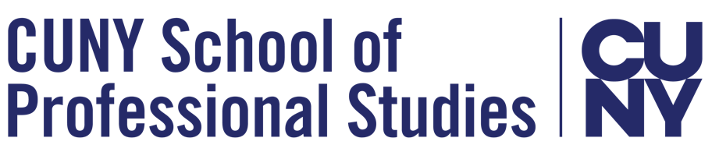

Citation Webinar - CUNY SPS Writing Fellows

Finding sources:

- The Newman Library: https://guides.newman.baruch.cuny.edu/SPS/
- CUNY OneSearch guide: https://guides.newman.baruch.cuny.edu/onesearch
- Live chat (24/7) or make a virtual appointment with a librarian about how to find sources for your project here: https://library.baruch.cuny.edu/help/
- Fall Library Updates: https://guides.newman.baruch.cuny.edu/ServiceUpdateSPS

Links for resources on citing sources using APA style:

- Purdue OWL APA 7th Edition Guide: https://owl.purdue.edu/owl/research_and_citation/apa_style/apa_formatting_and_style_guide/general_format.html
- Sample APA-formatted Papers: https://owl.purdue.edu/owl/research_and_citation/apa_style/apa_formatting_and_style_guide/apa_sample_paper.html
- APA References Examples: https://apastyle.apa.org/style-grammar-guidelines/references/examples

Zotero resources for managing citations:
- Sign up for a virtual Zotero workshop at the Newman Library: https://library.baruch.cuny.edu/students/library-instruction/workshops/
- Zotero (free citation manager): https://www.zotero.org
- Zotero Guide : https://guides.newman.baruch.cuny.edu/zotero
- ZoteroBib (online citation manager) : https://zbib.org/

Other resources:

- Using signal phrases to introduce quoted or paraphrased material (from Antioch College): https://www.antioch.edu/wp-content/uploads/2019/12/APA-7-12.-Signal-Phrases-APA.pdf
- CUNY’s Academic Integrity Policy: https://sps.cuny.edu/about/policies/academic-and-student-policies/academic-integrity

Need more help? The fastest way to get help is to schedule a live appointment with the CUNY SPS Writing Fellows. On your Blackboard course page, click “Tutoring” on the left sidebar and follow instructions to make an appointment.

If you have a question, contact the Writing Fellows via email: writingfellows@sps.cuny.edu
The Writing Fellows’ website: https://bacwritingfellows.commons.gc.cuny.edu/

